1. Install the software

https://download.rechargegrid.in/download/ADBForward.rar

2. Extract the rar file

Note : If RAR extension not available download and Install

http://mrechargesystem.com/Download/wrar390.exe

3. Open a adbforward folder

4. Right click on ADBForward.exe and give permission for administrator

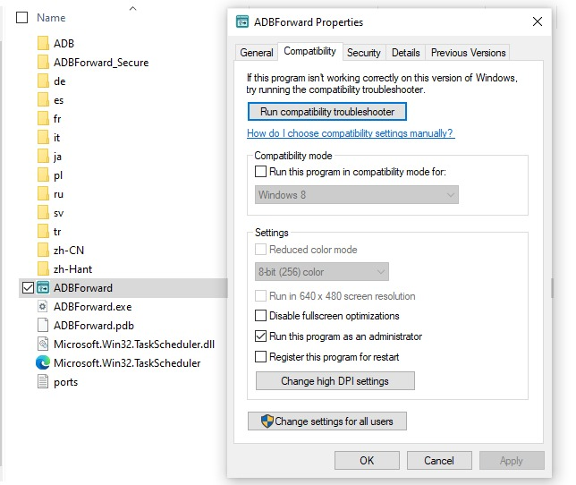

5. Connect device and show in device manager

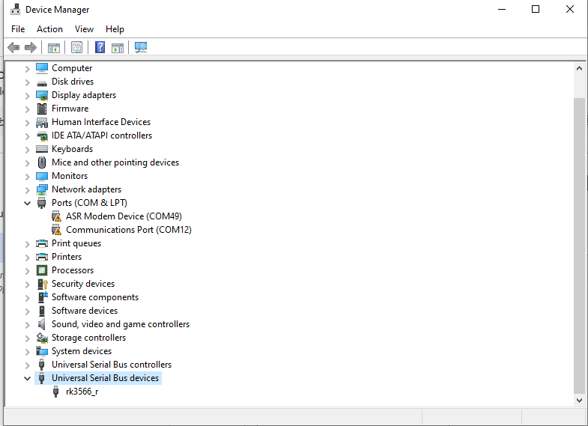

Note : If not show in Device Manager download
https://download.rechargegrid.in/download/zadig-2.9.exe

Open exe > Select Options > Click List All devices > select connected device and Replace Driver

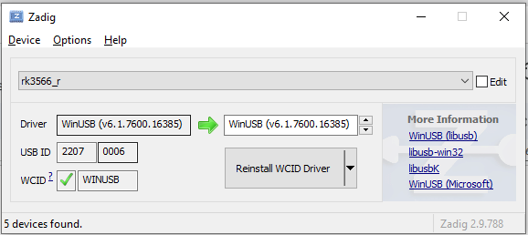
6. Start a application and show in trey (show hidden icons) and click on adbforward app

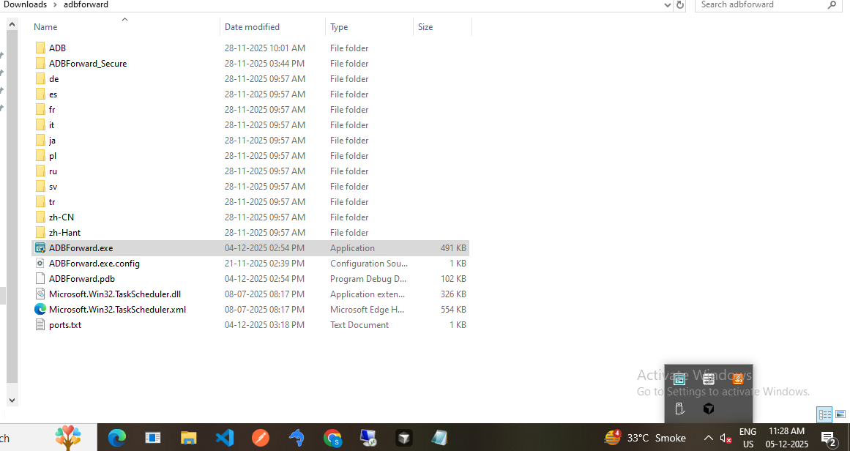

7. Show Status as forward

